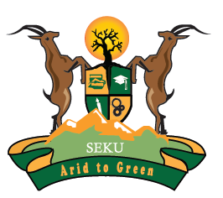

SOUTH EASTERN KENYA UNIVERSITY
UNIVERSITY EXAMINATIONS 2018/2019

SECOND SEMESTER EXAMINATION FOR THE DEGREE OF BACHELOR OF EDUCATION ARTS

CLT 402: AFRO-AMERICAN LITERATURE EXAMINATION

(WOTE AND MACHAKOS CAMPUSES)

DATE: 17TH APRIL, 2019 TIME: 1.30-3.30 PM

Answer Three Questions only. Question ONE is compulsory

- ( a) Outline the main issues that the African American slave must content with using, for reference
The Narrative Life of Frederick Douglas. (15 marks)
(b) Use any of the poems by Maya Angelou studied in this unit to argue for the African American
desire to rebrand the self as a way of deconstructing previously established notions of the
self. (15marks)
- Explore the effectiveness of the symbols in Lorraine Hansberry’s play A Raisin in the Sun and what they reveal about the Afro-American’s quest for justice and fairness. (20marks)
- Referring to the poetry by Langston Hughes, comment on the search and assertion of identity in the African American. (20marks)
- Maya Angelou,s I Know Why the Caged Bird Sings is the perfect tale of immense courage to overcome great odds and find meaning in life. Justify. (20marks)
- Examine the role and effectiveness of humour in the short stories anthology The Best of Simple by Langston Hughes. (20marks)
- Basing your arguments on either Martin Luther King Jr.’s speech I Have a Dream or the speech by Malcolm X The Ballot or the Bullet, discuss language use and its implications on the different options available to the Afro-American for dealing with race relations problem. (20marks)

